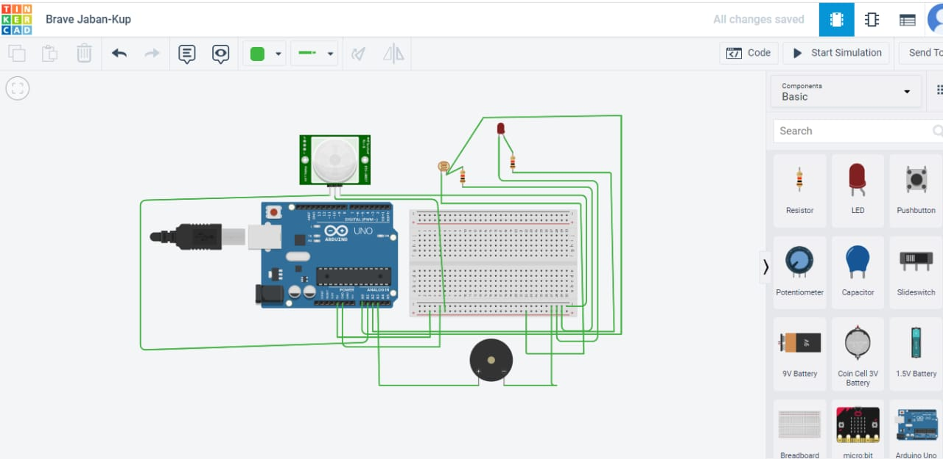const int photo=A0;

const int pir=A1;

const int led=A2;

const int buz=A3;

int a,b;

void setup()

{

pinMode(LED_BUILTIN, OUTPUT);

pinMode(photo,INPUT);

pinMode(pir,INPUT);

pinMode(led,OUTPUT);

pinMode(buz,OUTPUT);

Serial.begin(9600);

}

void loop()

{

digitalWrite(LED_BUILTIN, HIGH);

digitalWrite(photo,HIGH);

digitalWrite(pir,HIGH);

delay(1000); // Wait for 1000 millisecond(s)

digitalWrite(LED_BUILTIN, LOW);

digitalWrite(photo,LOW);

digitalWrite(pir,LOW);

delay(1000);

a=analogRead(pir);

if(a>0){

digitalWrite(buz,HIGH);

}

else{

digitalWrite(buz,LOW);

}

b=analogRead(photo);

if(b<450){

digitalWrite(led,HIGH);

}

else{

digitalWrite(led,LOW);

}

}

**Assignment 2:**

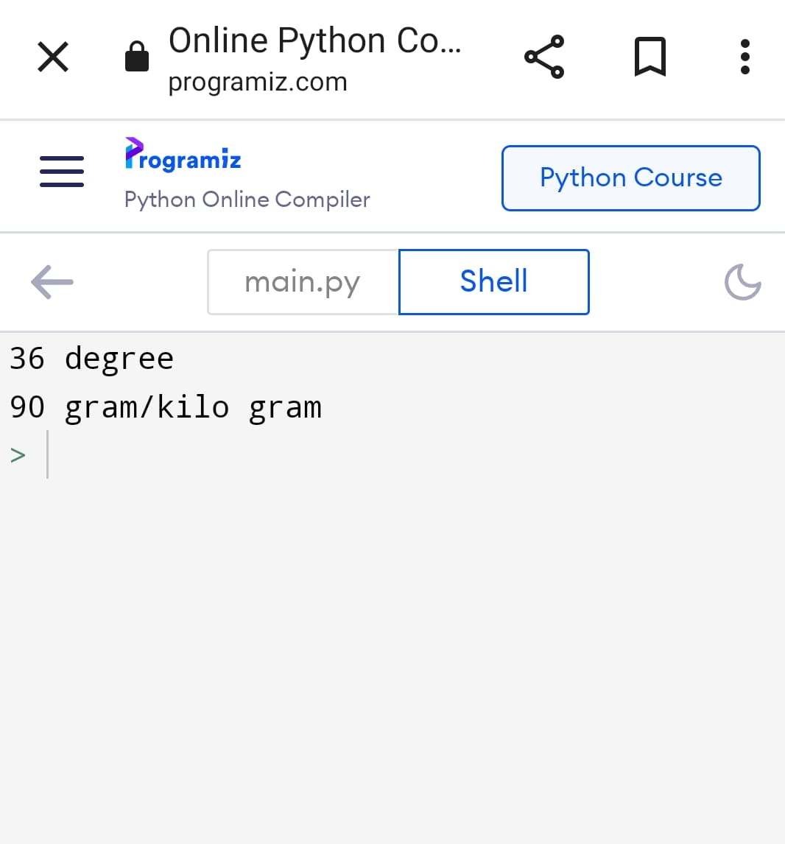

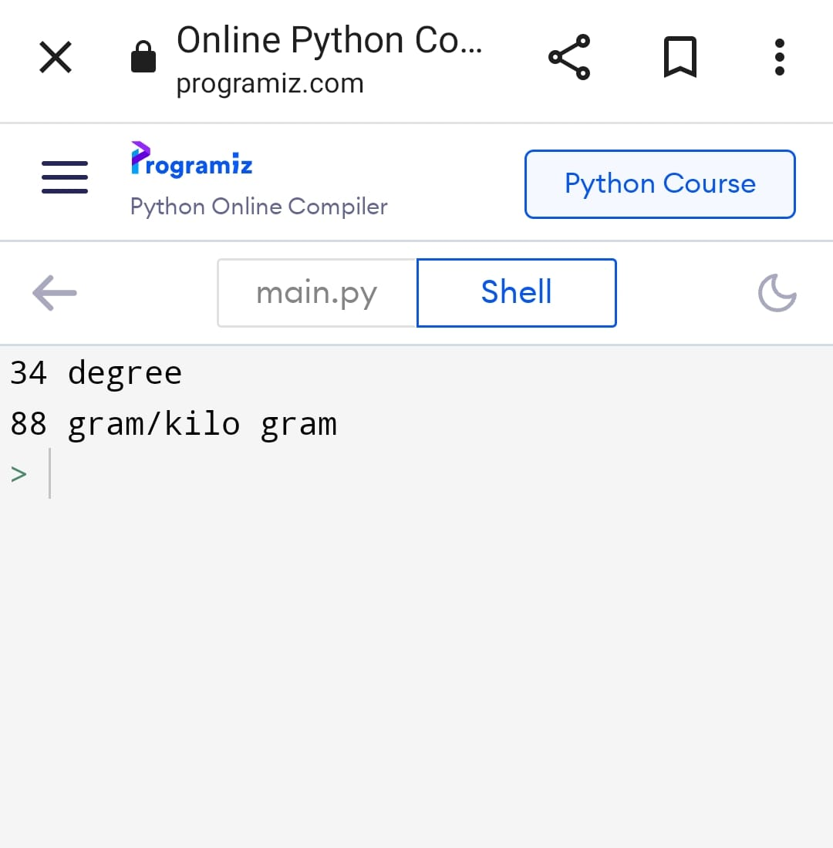

import random

temp=random.randint(0,100)

hum=random.randint(0,100)

if(temp>60):

print("/////alert the alarm /////")

else:

print(temp, "degree")

print (hum,"gram/kilo gram")

import RPi.GPIO as GPIO

import time

import signal

import sys

**Assignment 3:**

import RPi.GPIO as GPIO # Import Raspberry Pi GPIO library

from time import sleep # Import the sleep function from the time module

GPIO.setwarnings(False) # Ignore warning for now

GPIO.setmode(GPIO.BOARD) # Use physical pin numbering

GPIO.setup(8, GPIO.OUT, initial=GPIO.LOW) # Set pin 8 to be an output pin and set initial value to low (off)

# Setup

GPIO.setmode(GPIO.BCM)

GPIO.setup(9, GPIO.OUT)

GPIO.setup(10, GPIO.OUT)

GPIO.setup(11, GPIO.OUT)

# Loop forever

while True:

# Red

GPIO.output(9, True)

GPIO.output(8, GPIO.HIGH) # Turn on

sleep(1) # Sleep for 1 second

GPIO.output(8, GPIO.LOW) # Turn off

sleep(1) # Sleep for 1 second

GPIO.output(8, GPIO.HIGH) # Turn on

sleep(1) # Sleep for 1 second

# Red and amber

GPIO.output(10, True)

GPIO.output(8, GPIO.LOW) # Turn off

sleep(1) # Sleep for 1 second

# Green

GPIO.output(9, False)

GPIO.output(10, False)

GPIO.output(11, True)

GPIO.output(8, GPIO.HIGH) # Turn on

sleep(1) # Sleep for 1 second

GPIO.output(8, GPIO.LOW) # Turn off

sleep(1) # Sleep for 1 second

GPIO.output(8, GPIO.HIGH) # Turn on

sleep(1) # Sleep for 1 second

GPIO.output(8, GPIO.LOW) # Turn off

sleep(1) # Sleep for 1 second

# Amber

GPIO.output(11, False)

GPIO.output(10, True)

GPIO.output(8, GPIO.HIGH) # Turn on

sleep(1) # Sleep for 1 second

GPIO.output(8, GPIO.LOW) # Turn off

sleep(1) # Sleep for 1 second

# Amber off (red comes on at top of loop)

GPIO.output(10, False)